Ex.no:3 | DATA CLEANING
Date:

Aim:
To identify and handle missing values, duplicate records, outliers, inconsistent data, and perform data transformation techniques such as normalization and encoding using Python Pandas.
Algorithm:
Check Missing Values:
- Start.
- Import the pandas library.
- Load the dataset into a DataFrame (df).
- Display dataset information using df.info().
- Check missing values using df.isnull().
- Count missing values using df.isnull().sum().
- Check missing values using df.isna().
- Check non-missing values using df.notnull().
- Display the results.

Drop Missing Values
- Start.
- Import the pandas library.
- Load the dataset into a DataFrame (df).
- Drop missing rows using dropna().
- Drop rows (axis=0) or columns (axis=1).
- Use how='any' to remove rows/columns containing any missing value.
- Use how='all' to remove rows/columns only if all values are missing.
- Use thresh=N to keep rows/columns with at least N non-missing values.
- Use subset=['column_name'] to drop rows based on specific columns.
- Use inplace=True to modify the original DataFrame.
- Display the cleaned DataFrame.

Program:
import pandas as pd
# Load dataset
df = pd.read_excel("sales data.xlsx")

print("===== DATASET INFO =====")
df.info()

print("\n===== MISSING VALUES IN EACH COLUMN =====")
print(df.isnull().sum())

print("\n===== TOTAL MISSING VALUES =====")
print(df.isnull().sum().sum())

print("\n===== ANY MISSING VALUES? =====")
print(df.isnull().values.any())

print("\n===== NON-MISSING VALUES COUNT =====")
print(df.notnull().sum())

import pandas as pd
df = pd.read_excel(“sales data.xlsx")

# Fill all missing values with 0
df_constant = df.fillna(0)
print("===== CONSTANT VALUE =====")
print(df_constant.head())

# Remove duplicate rows
df.drop_duplicates(inplace=True)
# Calculate interquartile range
Q1 = df['price'].quantile(0.25)
Q3 = df['price'].quantile(0.75)
IQR = Q3 - Q1
lower = Q1 - 1.5 * IQR
upper = Q3 + 1.5 * IQR

outliers = df[(df['price'] < lower) |
(df['price'] > upper)]

print(outliers)
# Create revenue boxplot
import matplotlib.pyplot as plt

plt.figure(figsize=(8,5))
plt.boxplot(df["total_revenue"])
plt.title("Outlier Detection in Total Revenue")
plt.ylabel("Total Revenue")
plt.show()

# Create scaler object
from sklearn.preprocessing import MinMaxScaler
scaler = MinMaxScaler()
df[['total_revenue']] = scaler.fit_transform(df[['total_revenue']])
print(df[['total_revenue']])

# Convert categories into columns
df = pd.read_csv("C:/Users/ramya/Downloads/archive (4).zip", compression="zip")
one_hot = pd.get_dummies(df["product_category"])
print(one_hot.head())

# Convert categories into numbers
one_hot = pd.get_dummies(df["product_category"], dtype=int)
print(one_hot.head())

Output:
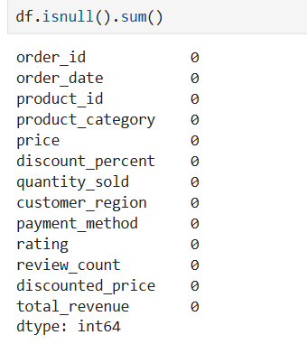

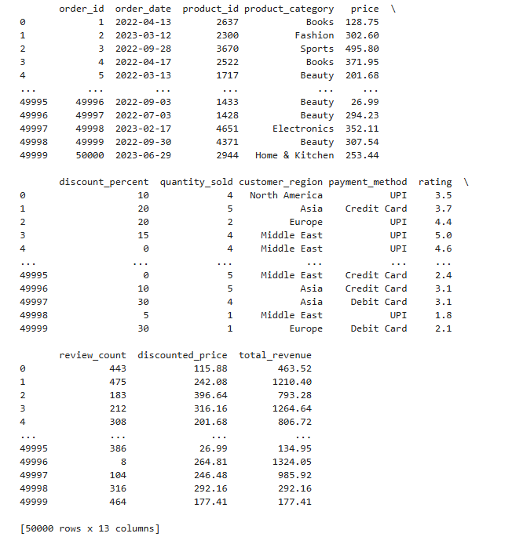
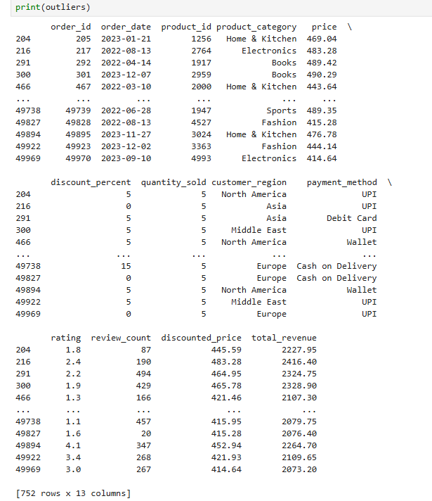

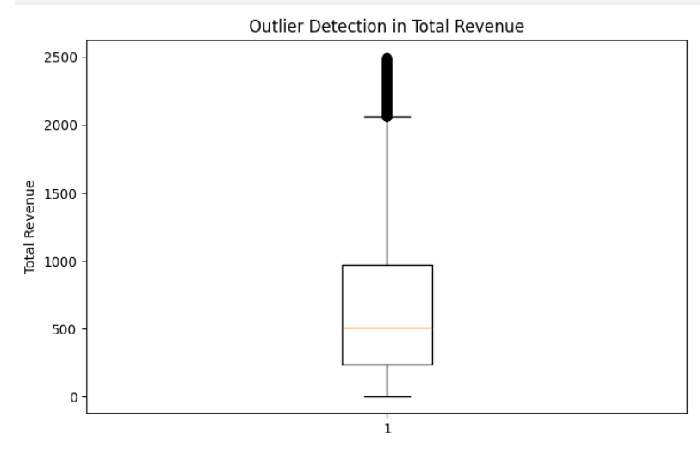
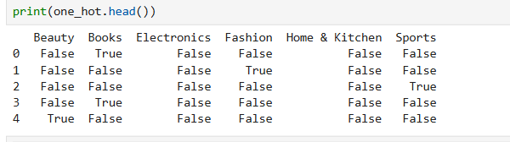

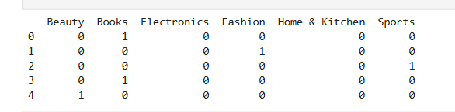

Result:

